1 - Authentication process using client, authentication server(keycloak), and resource server

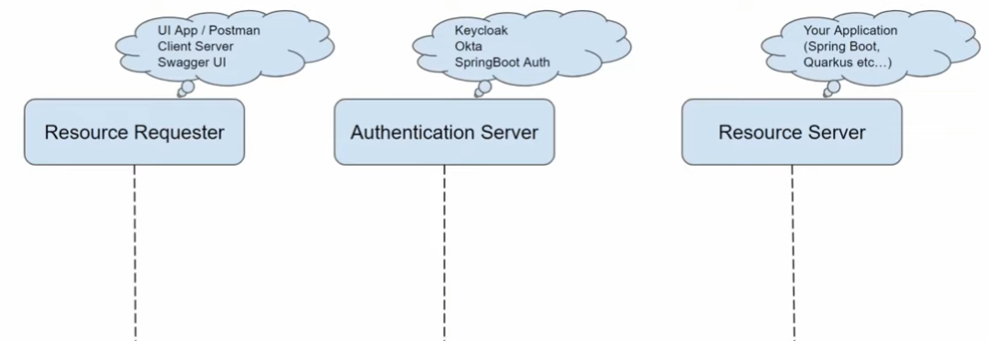2

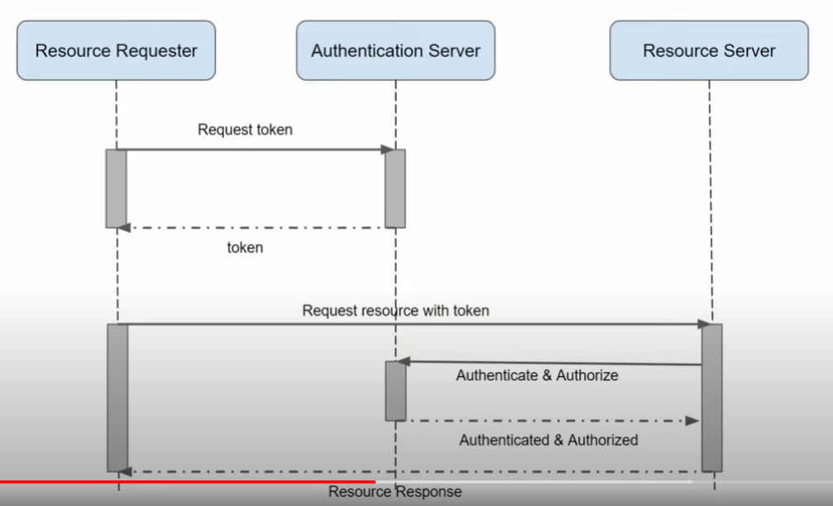3 – Client – server - 1

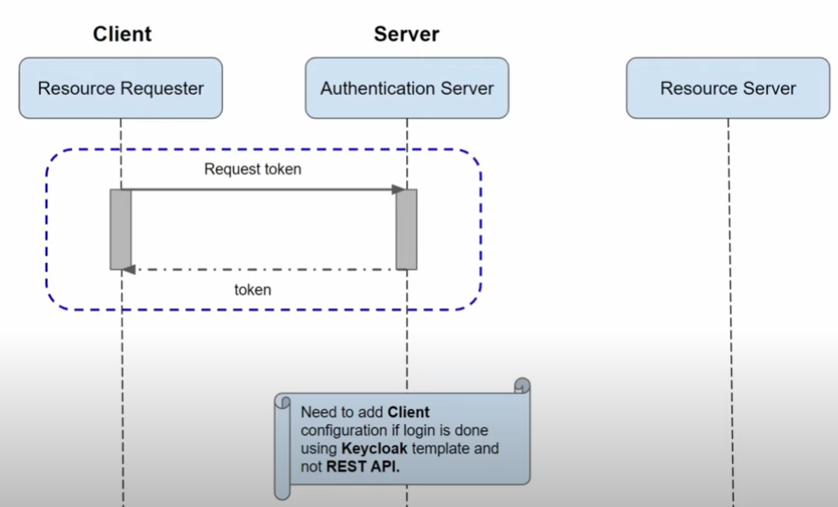4

4 – Client – server – 2

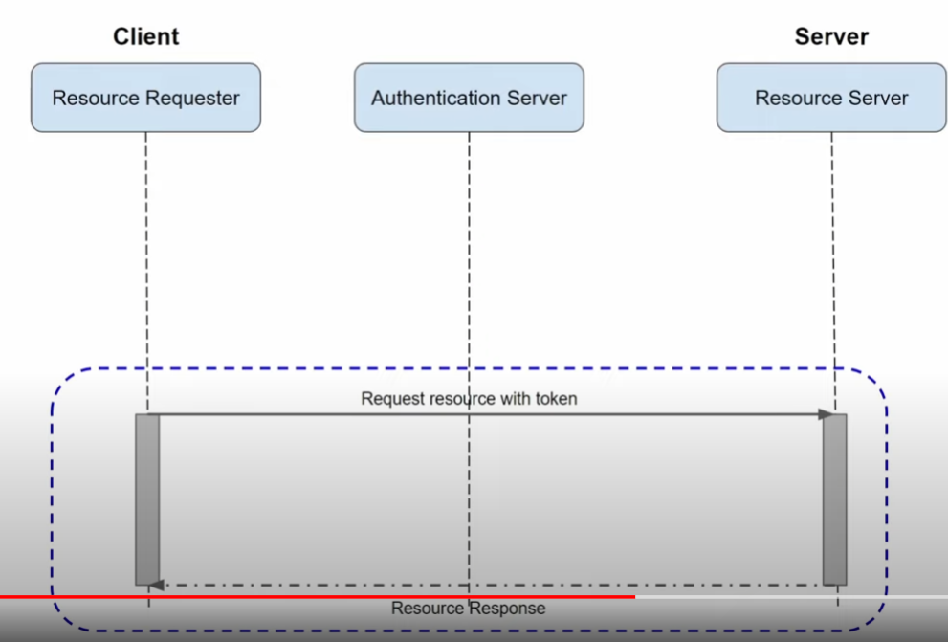5 – Client -Server – 3

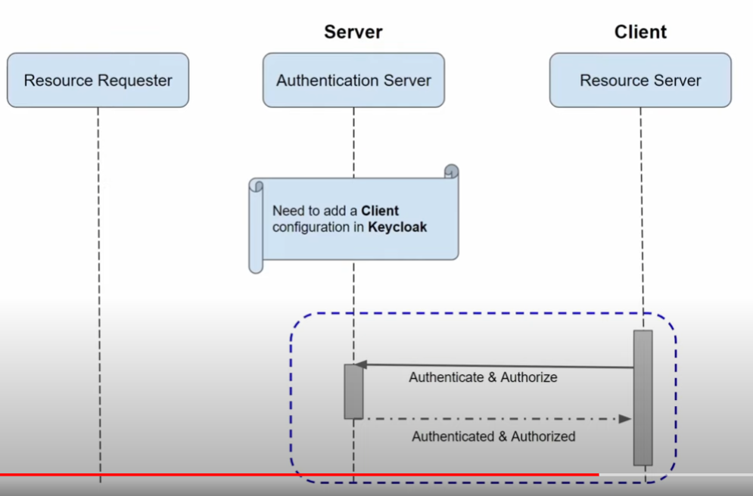6

6 – Client = UI/PostMan

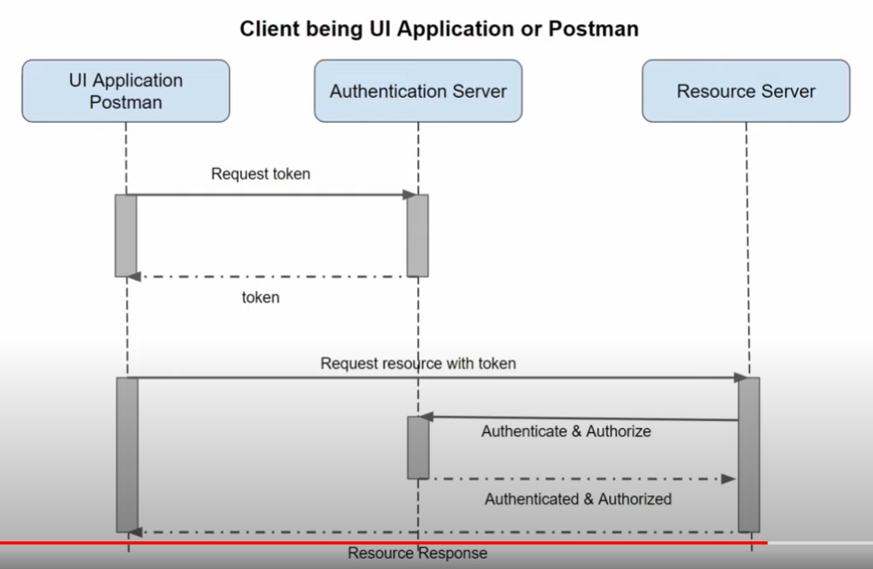

7 - Client – server – Auth server – Res Server

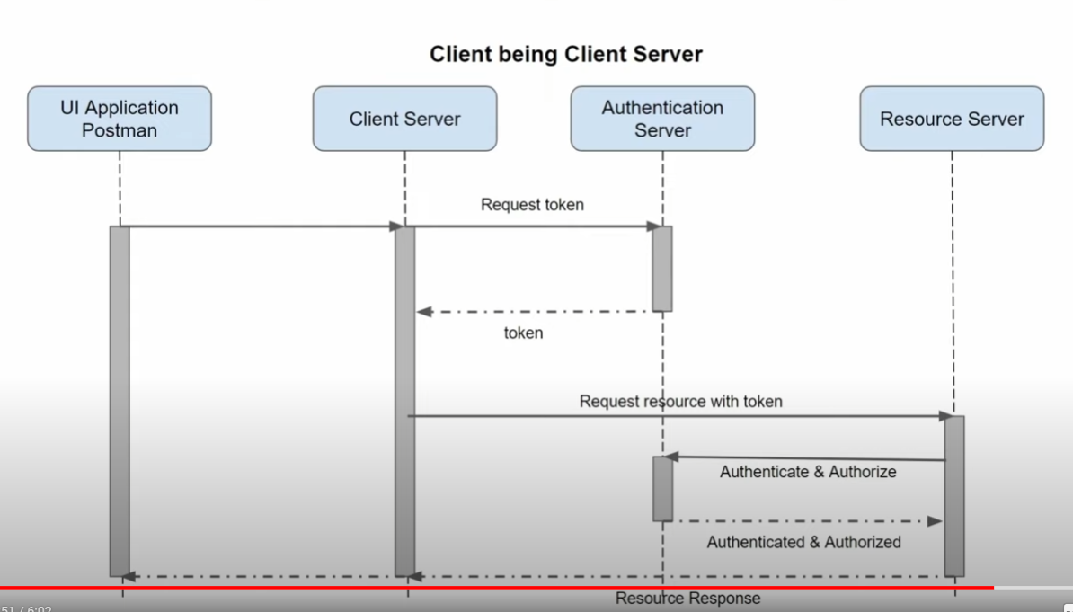8 -

9 – Client (Swagger UI within Resource Server)

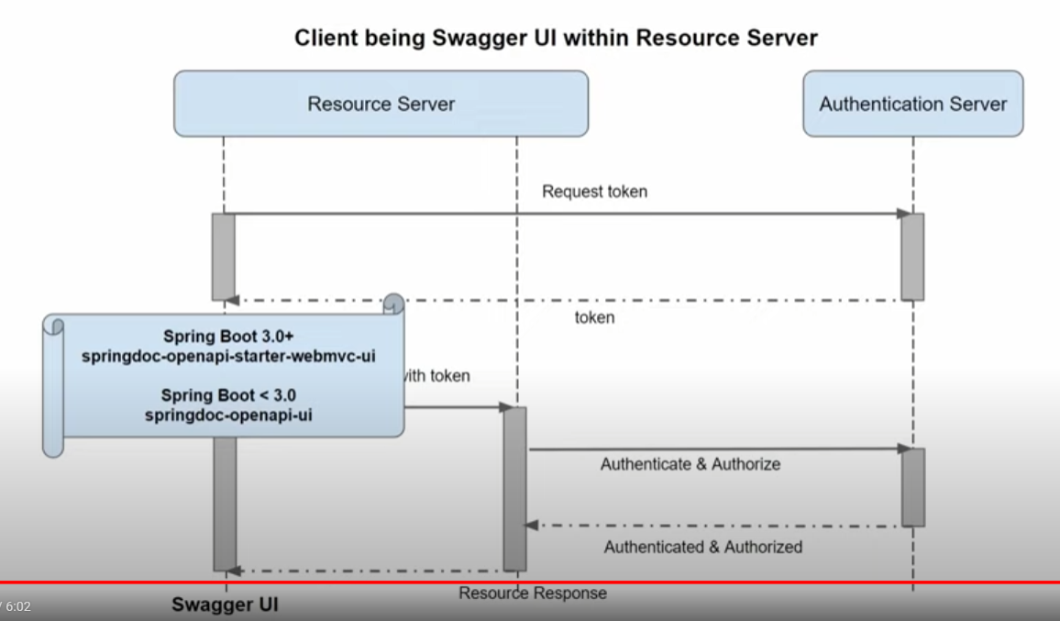

10 - Using keycloak APIs to generate token, check the validity, and logout the user.

A - Generate Token, check user sessions

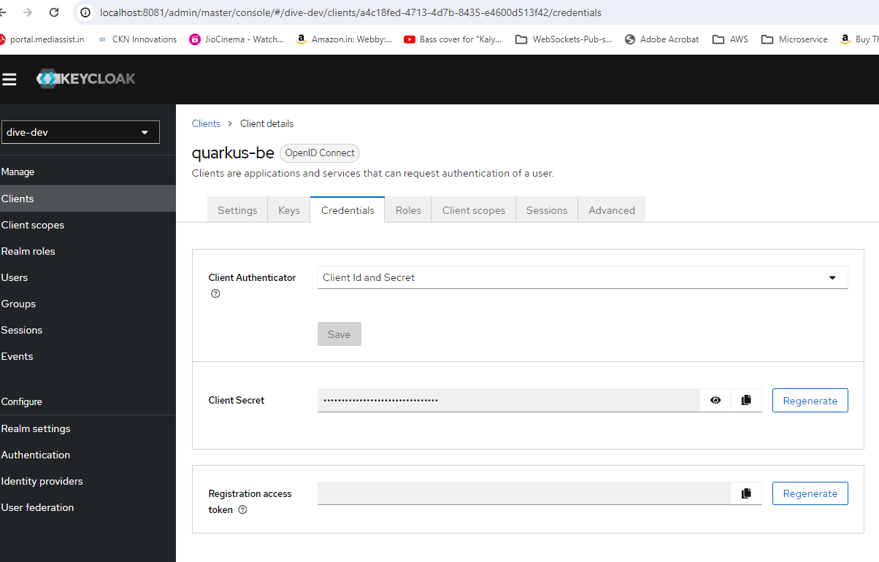

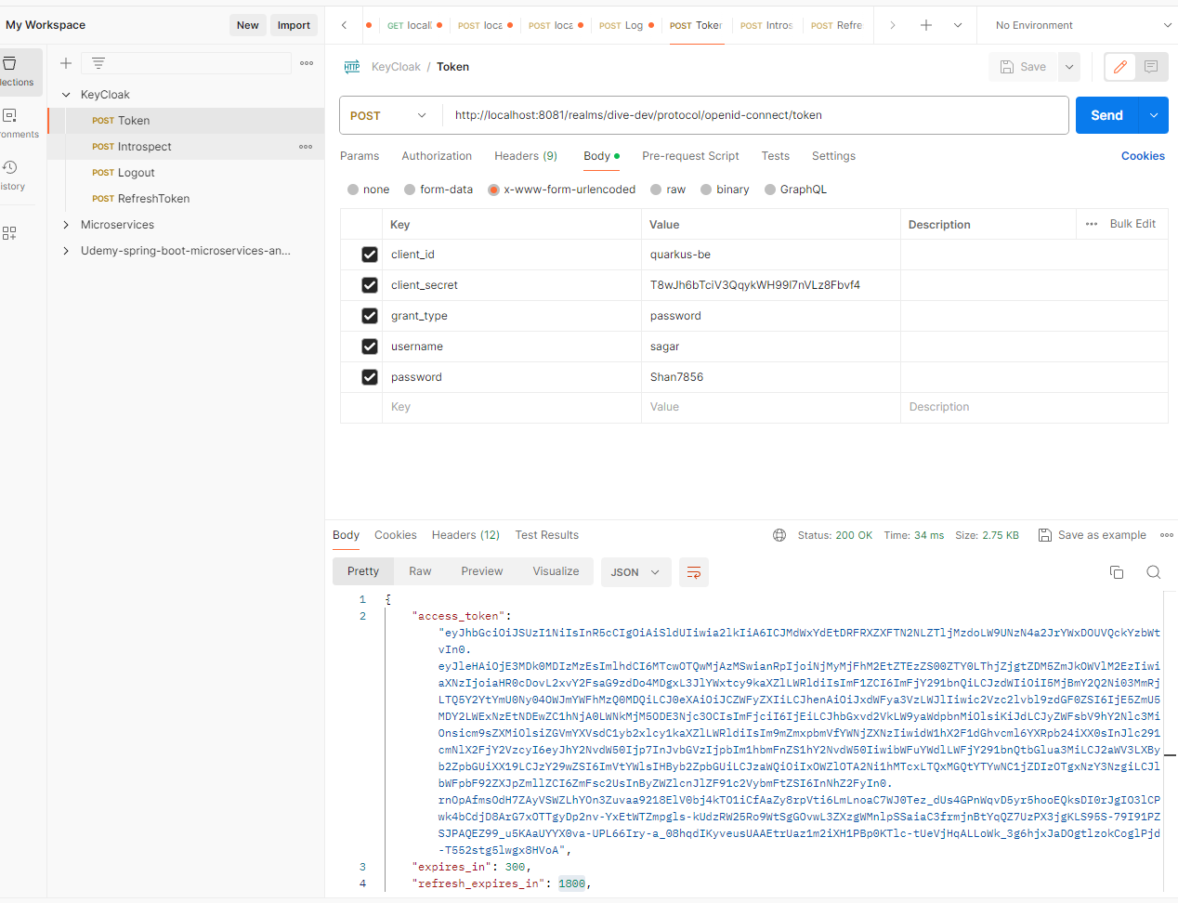

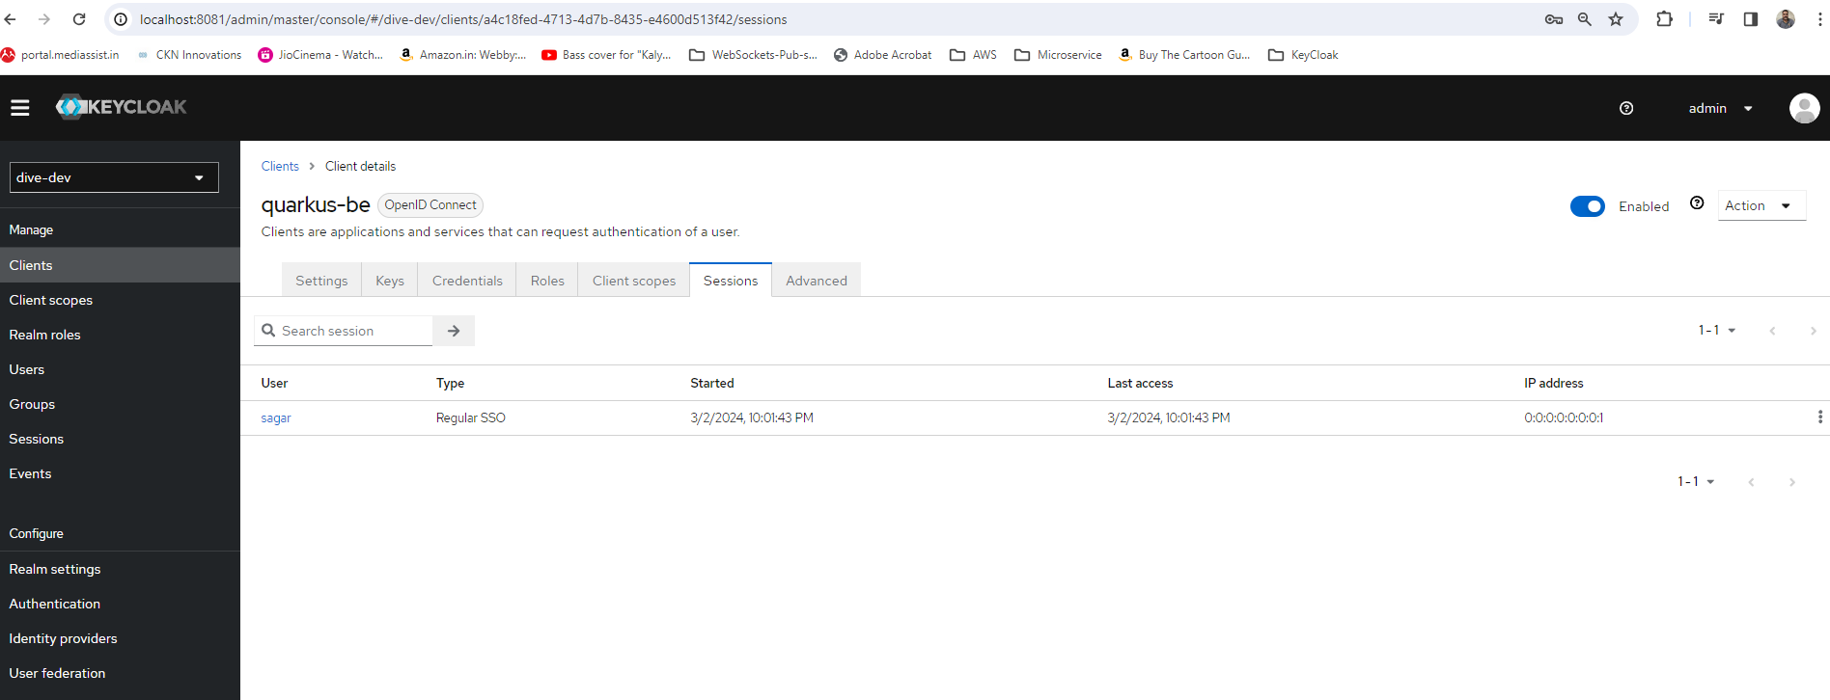

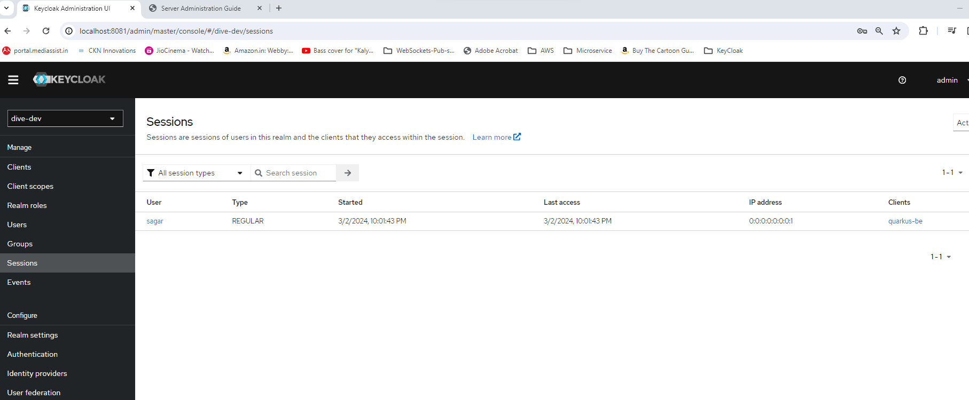

POST

http://localhost:8081/realms/dive-dev/protocol/openid-connect/token

client_id quarkus-be

client_secret T8wJh6bTciV3QqykWH99l7nVLz8Fbvf4

grant_type password

username sagar

password Shan7856

11 – B – Check Validity, introspect token

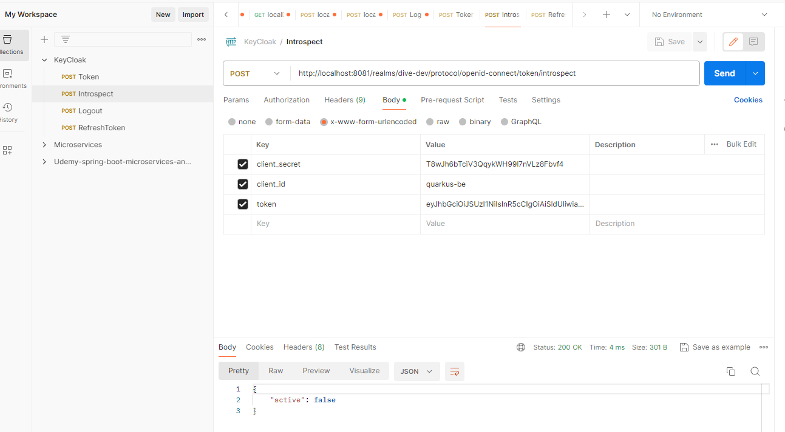

http://localhost:8081/realms/dive-dev/protocol/openid-connect/token/introspect

token

client_id quarkus-be

client_secret T8wJh6bTciV3QqykWH99l7nVLz8Fbvf4

12 – Logout

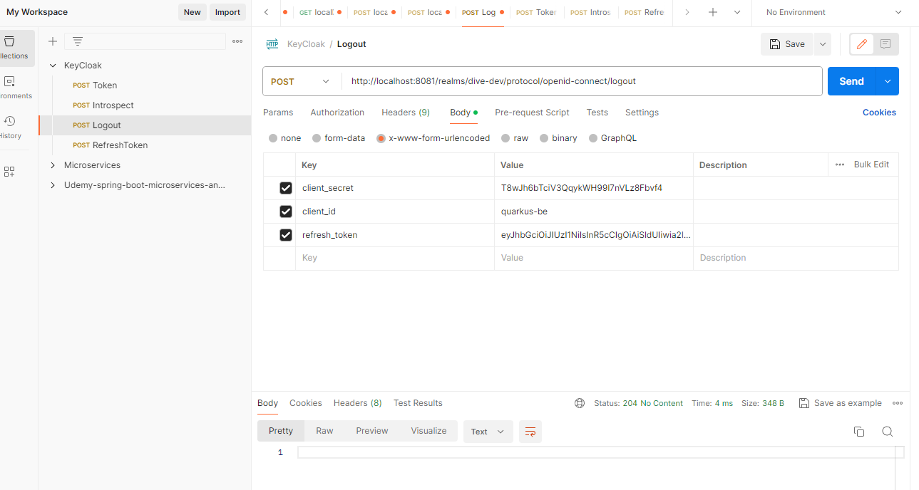

http://localhost:8081/realms/dive-dev/protocol/openid-connect/logout

client_id quarkus-be

client_secret T8wJh6bTciV3QqykWH99l7nVLz8Fbvf4

refresh_token

13 – Refresh token

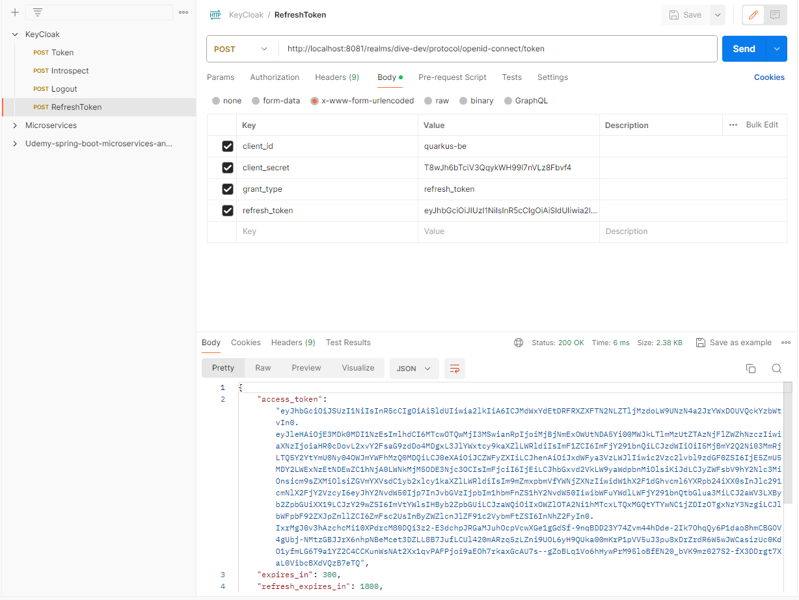Refresh - token http://localhost:8081/realms/dive-dev/protocol/openid-connect/token

client_id quarkus-be

client_secret T8wJh6bTciV3QqykWH99l7nVLz8Fbvf4

grant_type refresh_token

refresh_token

14 –Increase Authentication token expiry time

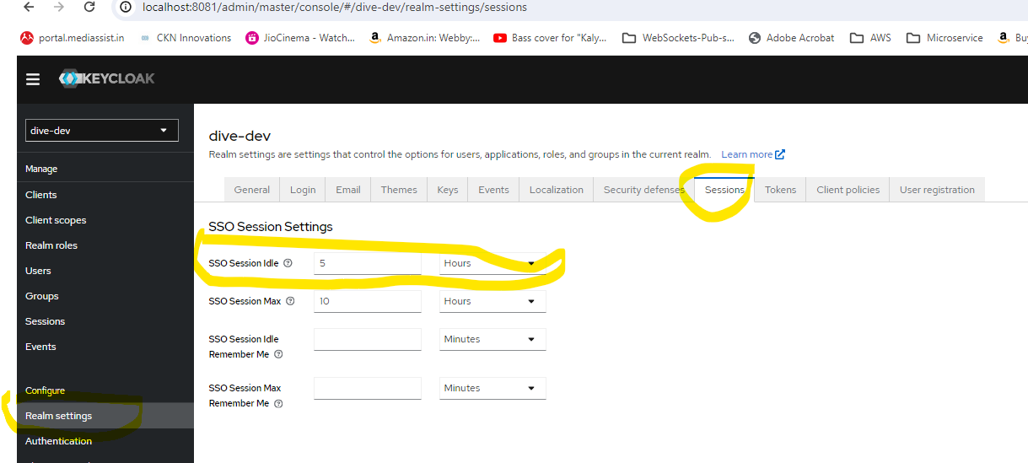

15 – Increase Refresh token Expiry time

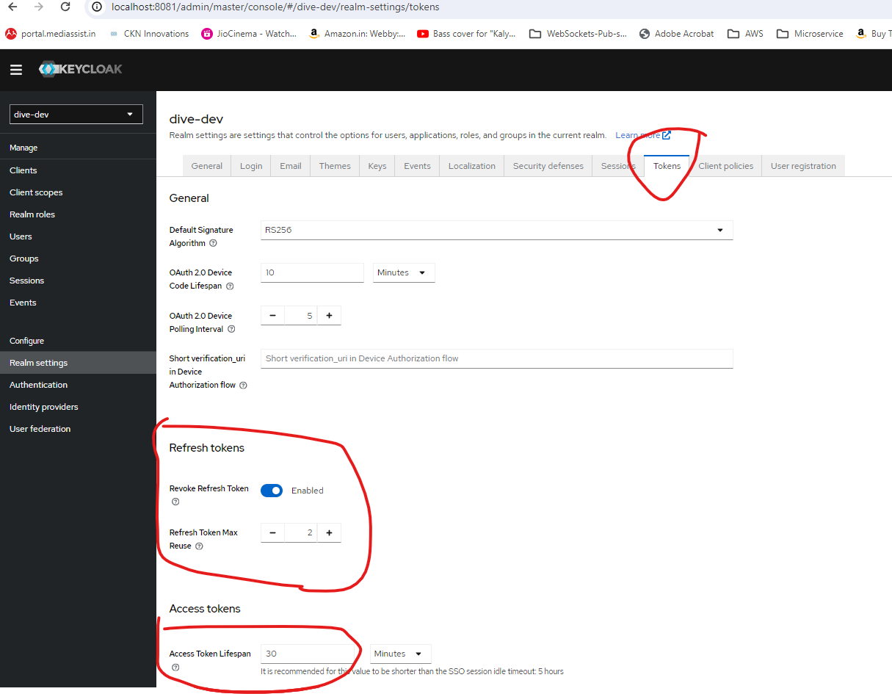

16 – Resource Server Use case

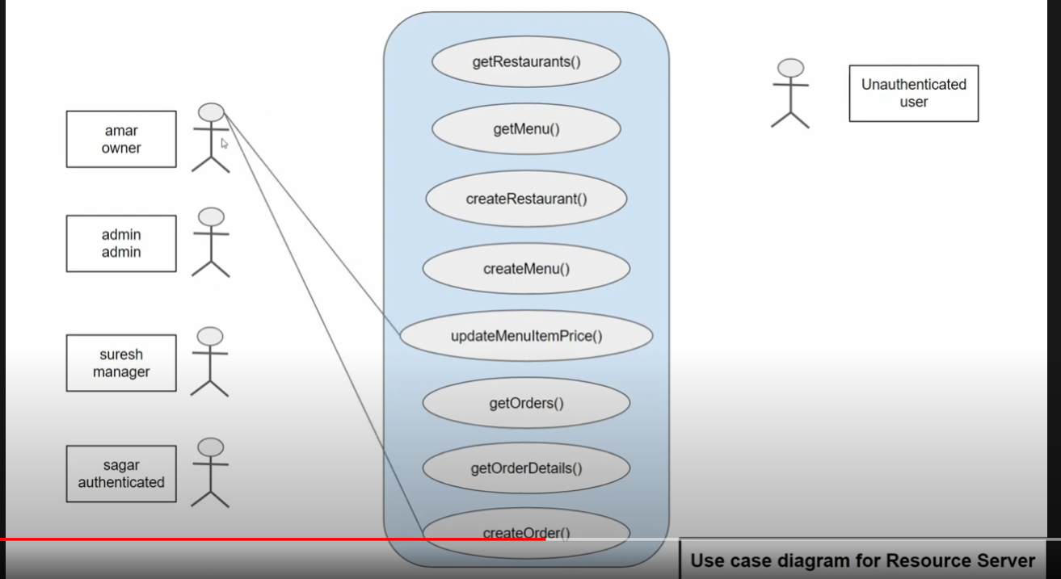

17 -

**Part 7.1 - Spring boot authentication process using oauth2 resource server and Keycloak**

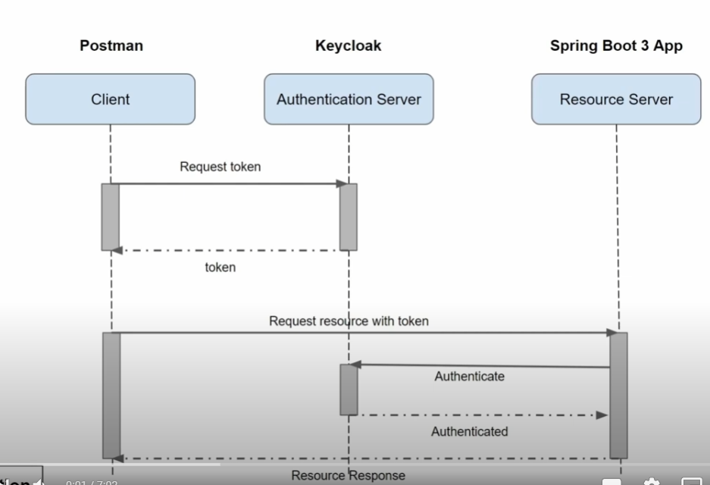

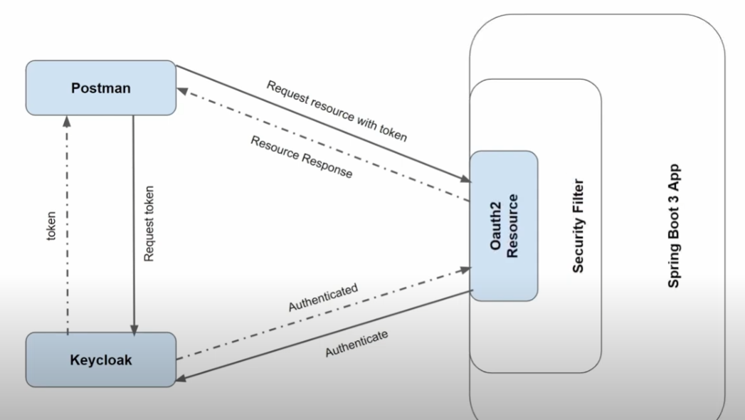

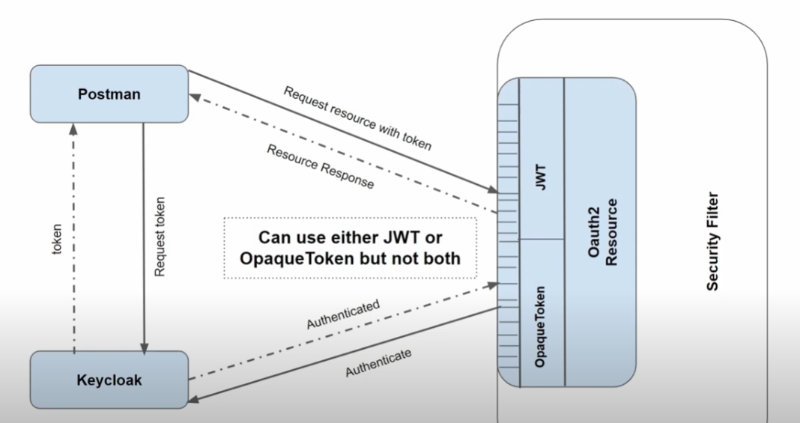

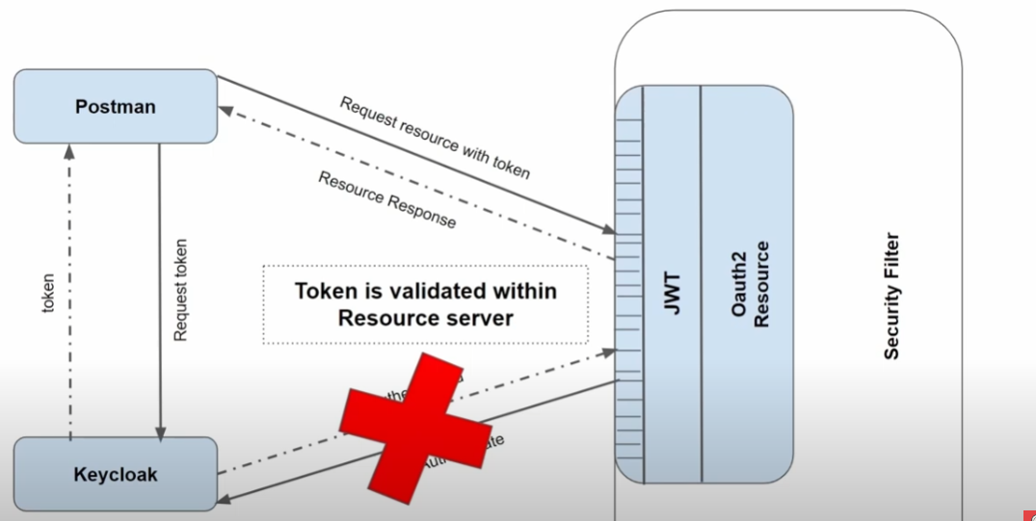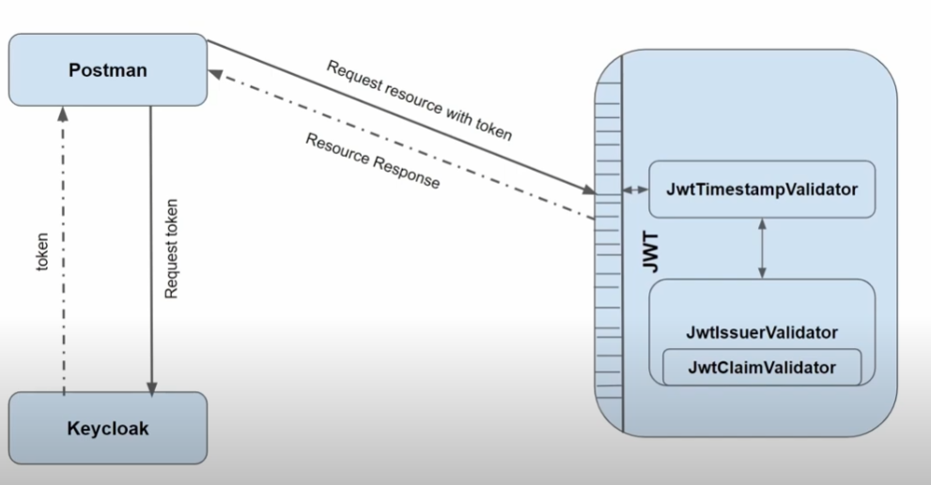

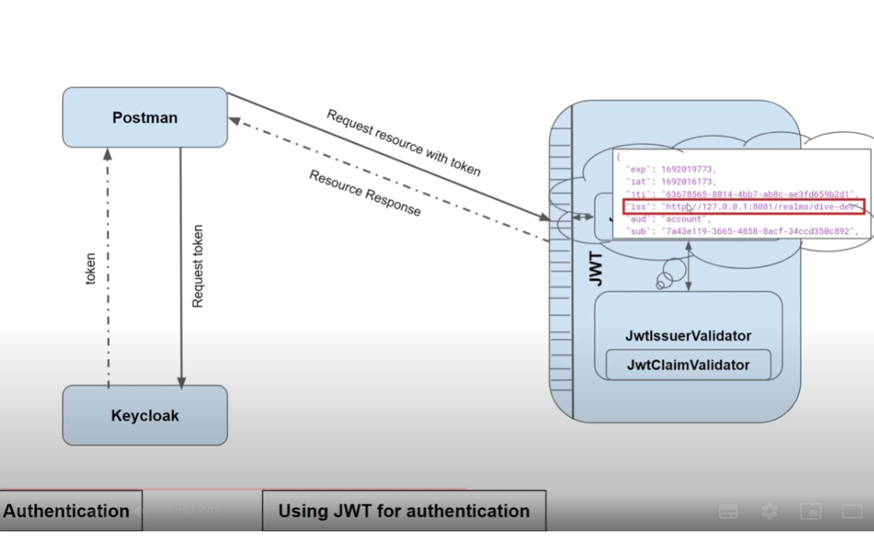

18 -

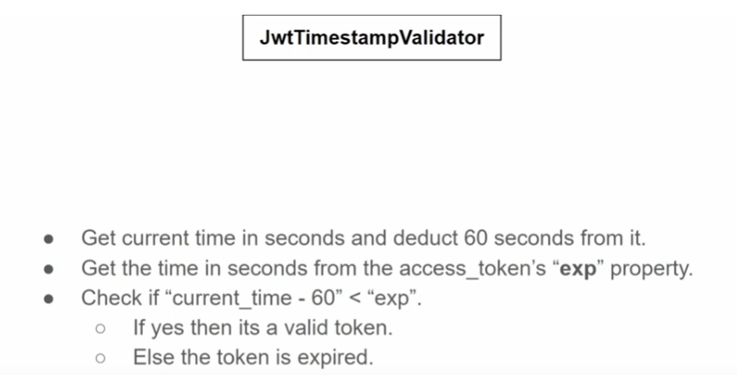

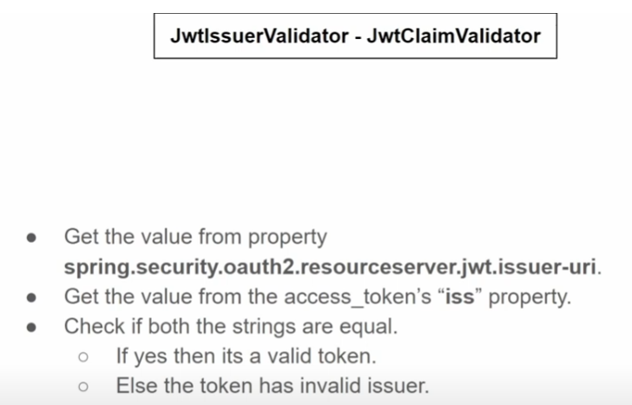

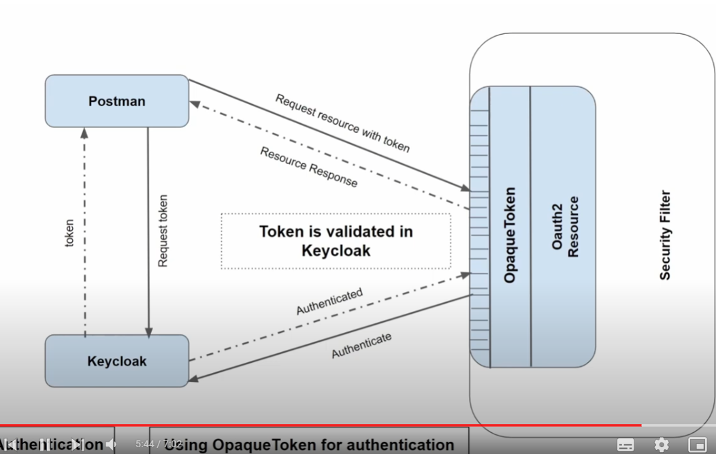

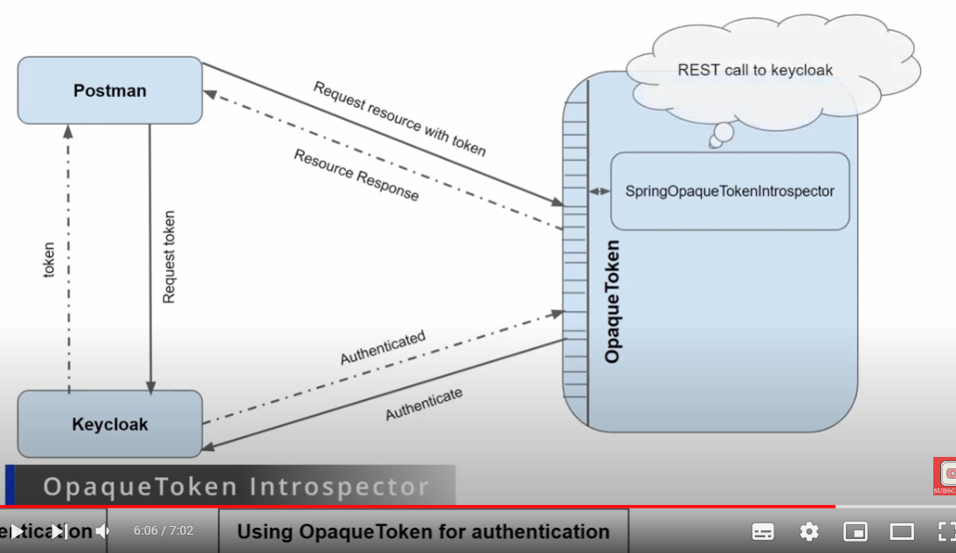

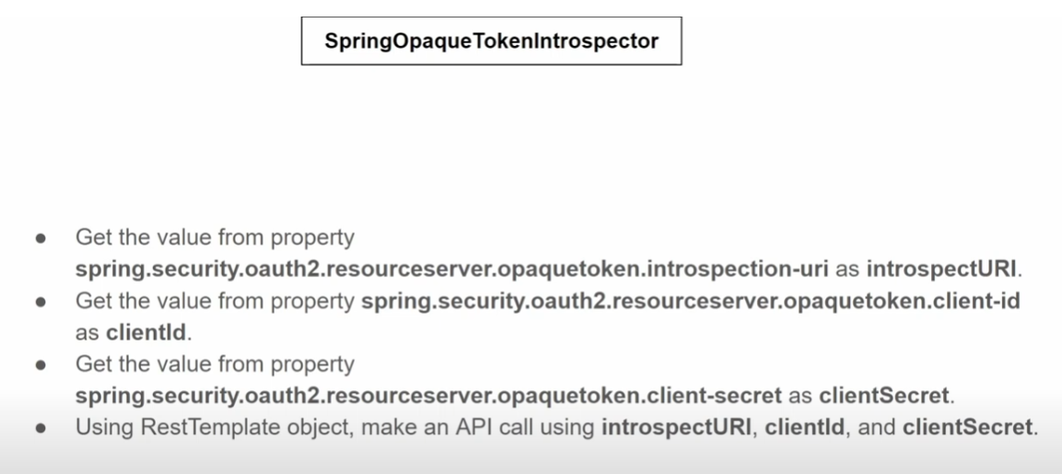

19 – Authorization – Neither JWT or Opaques sends request to Keyclock for Authorization

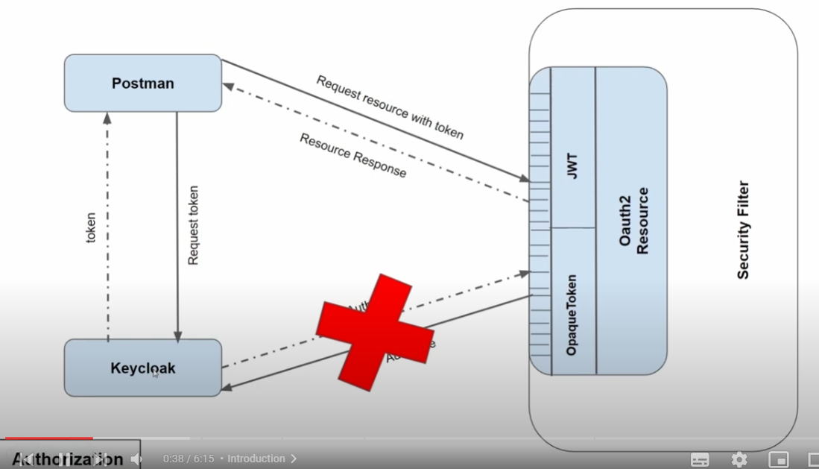

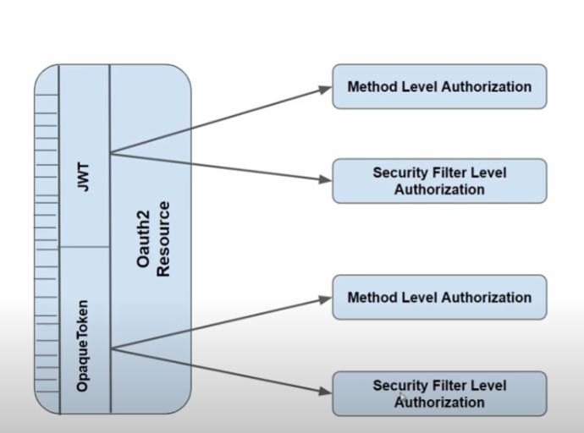

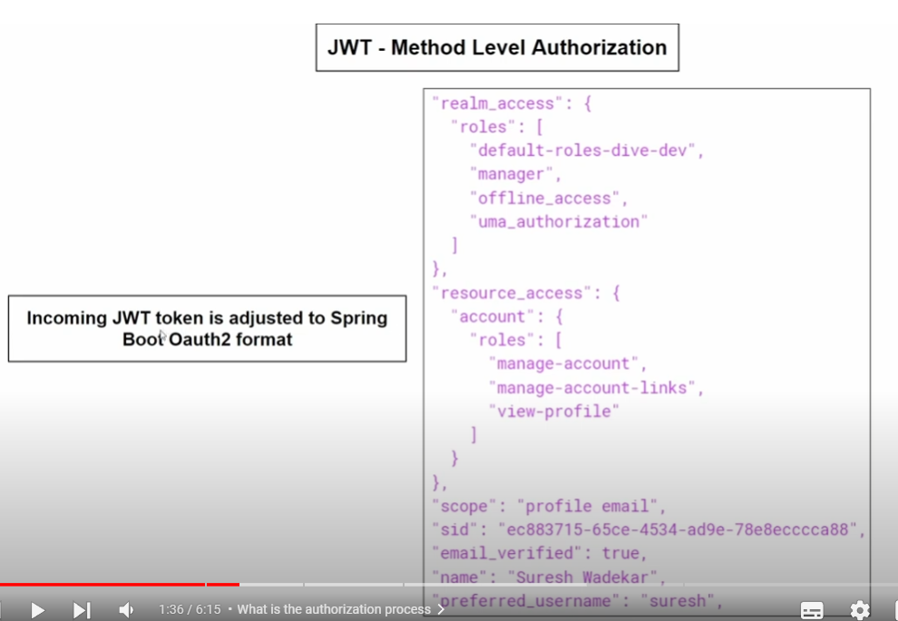

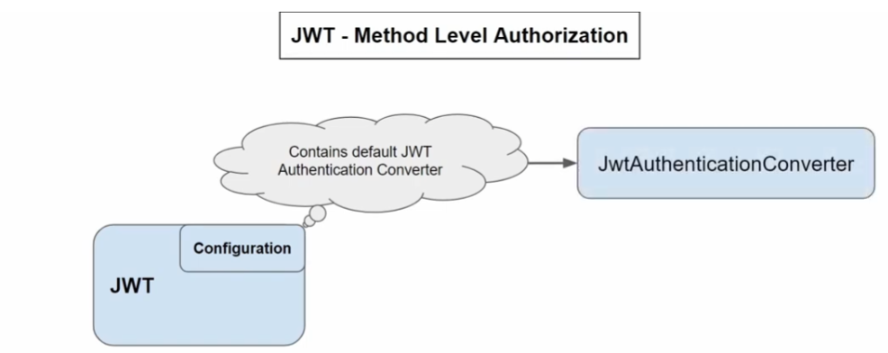

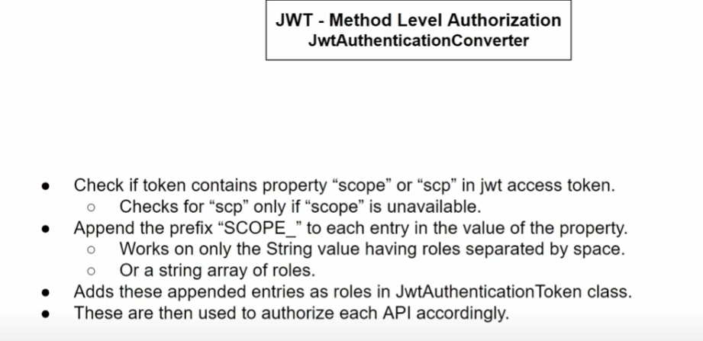

Basic JWTAuthenticationConverter checks for “scope” or “scp”

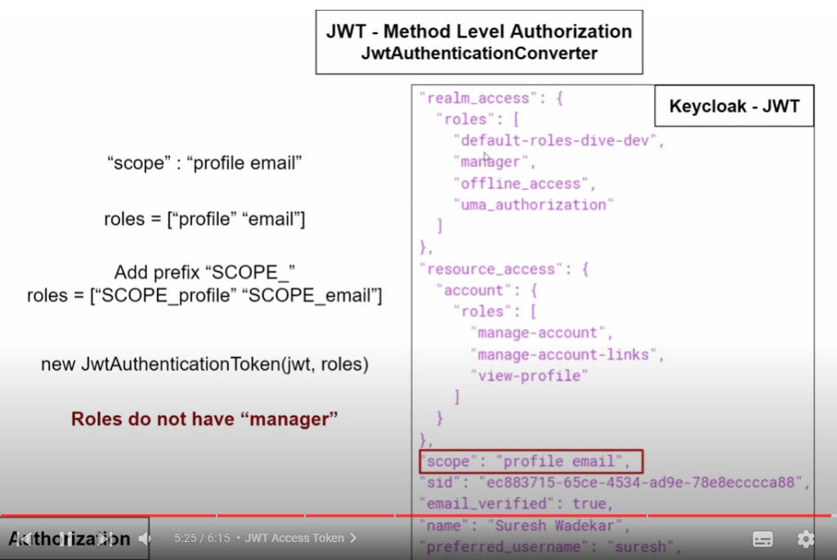

Add security filter for public access

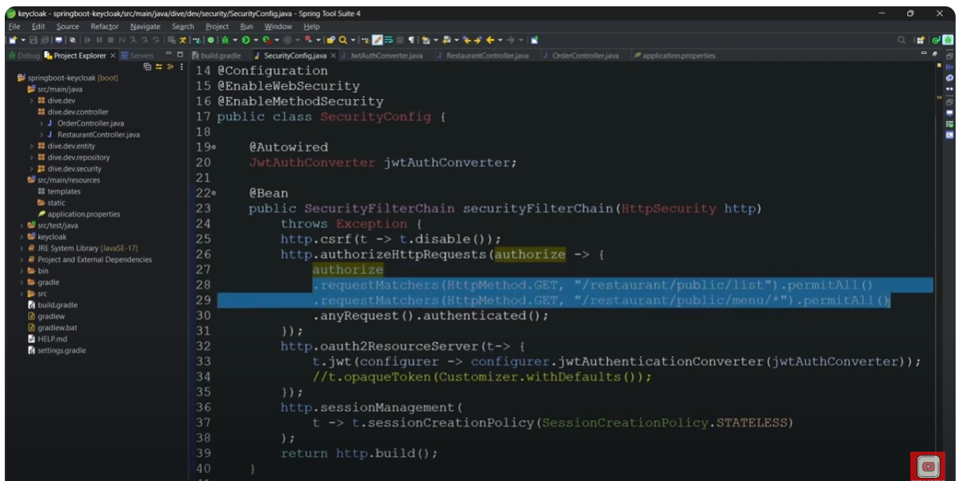

For JWT – add jwt-issuer uri

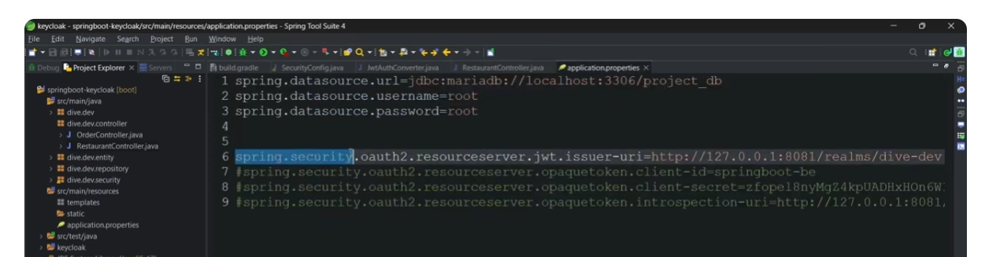Override default converter to JWTAuthConverter (custom implementation)

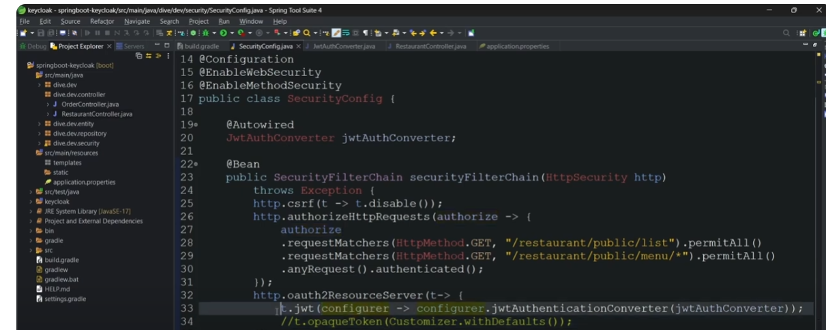

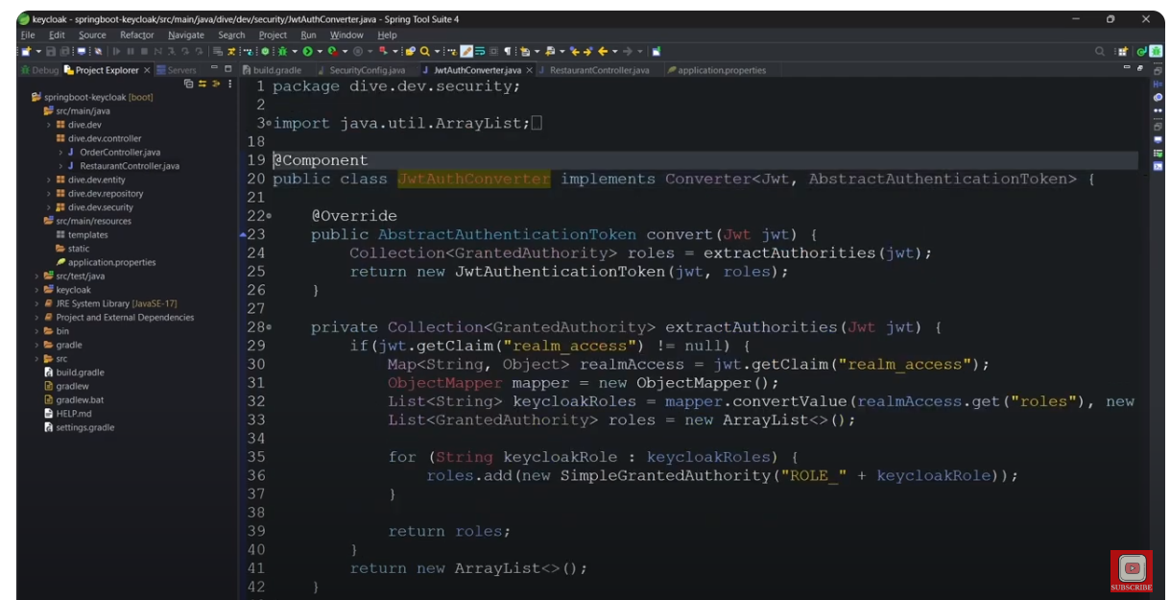

Built custom method security handler to be replaced with Default Method Securtiy Handler – “To remove the ROLE_” string prepended and just use the role what we get in JWT

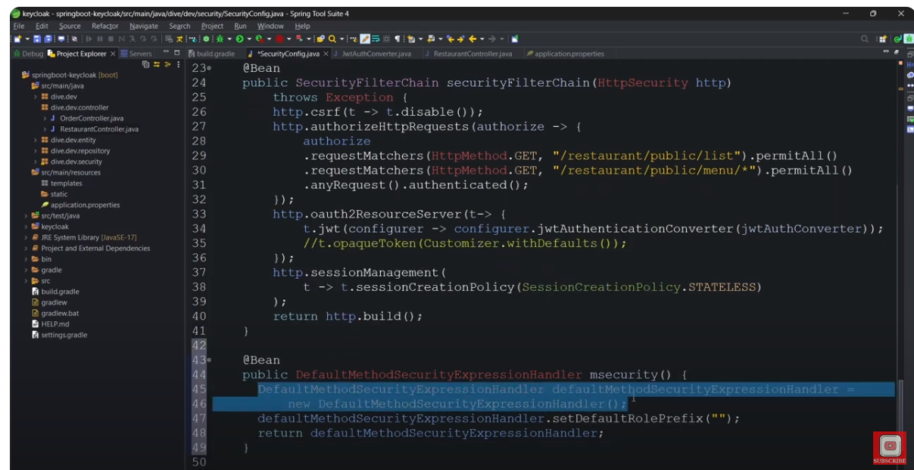

Without using user defined Auth converter class – I.e access from “roles” in jwt token. For this, add a roles a separate property In jwt json in keycloak

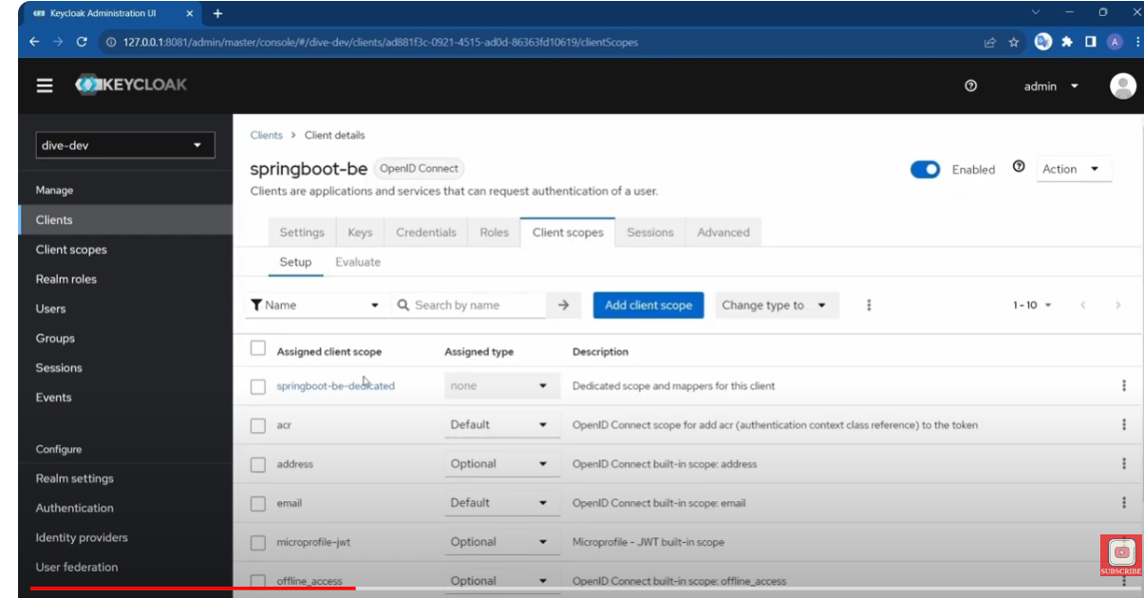

Configure new mapper for “”springboot-be” in “User Realm Role”

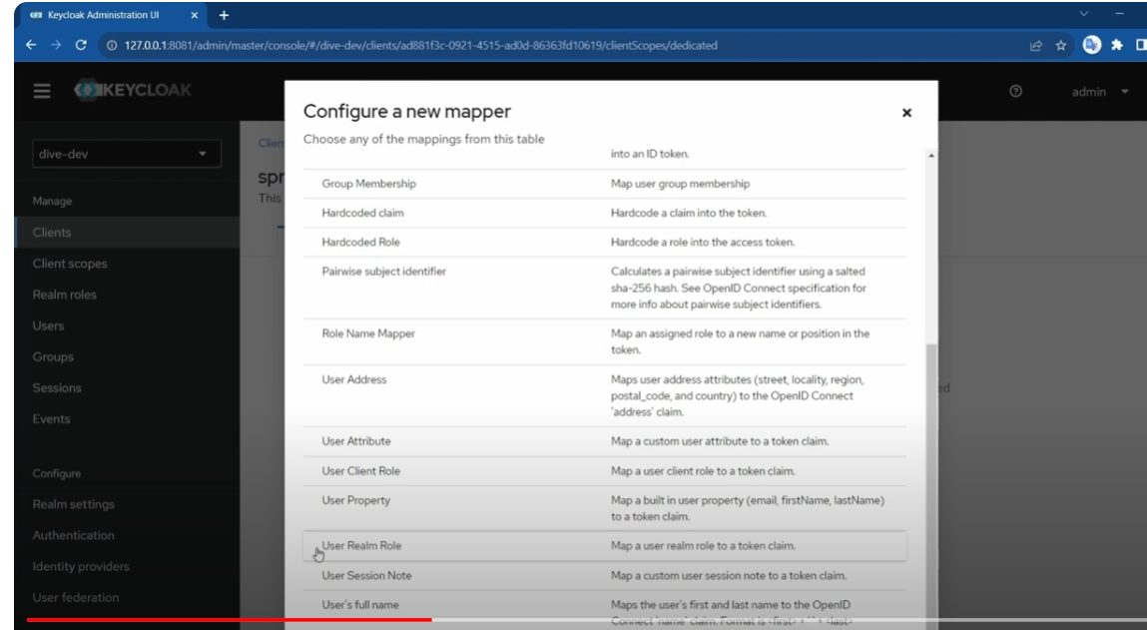

roles, multivalued, add to access token

